**1. Please determine is it economically viable to replace an CFL lamp with an LED lamp? Use the levelized cost method to determine the cost of lighting in Rp/lumen using following data**

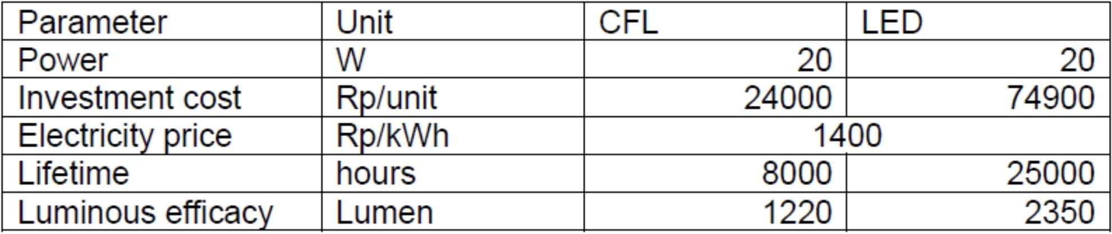

$$LCOA=\frac{Investment cost+Lifetime energy cost}{Lifetime Lumen}$$

$$LCOA=\frac{Investment cost+\left(Electricity price*Power*Lifetime\right)}{Luminous efficacy*Lifetime}$$

|  |  |
| --- | --- |
| **CFL lamp** | **LED lamp** |
| $$LCOA=\frac{24000+\left(1400*0.02*8000\right)}{1220*8000}$$ $$LCOA=Rp 0.025 /Lumen$$ | $$LCOA=\frac{74900+\left(1400*0.02*25000\right)}{2350*25000}$$ $$LCOA=Rp 0.013 /Lumen$$ |

CFL lamps have lower LCOA (Rp/lumen) as compared to LED lamps. Hence, it is **not** economically viable to replace it with LED lamp.

**2. Please elaborate the energy conservation strategy in industry sector! Also please compare it to the current Indonesia’s industrial practice.**

A key step for energy conservation in industry sector is to conduct regular Energy Audit and apply Energy Management System within the company. Constant monitoring and evaluation of energy utilization helps identify potential energy use optimization and is one of the most effective strategies in reducing energy consumption and costs. Putting it into actions, shifting to energy-efficient technologies such as high-efficiency lighting and HVAC systems can reduce energy consumption. For processing industries, process optmization, including upgrading equipment and recovering waste heat, also helps in significantly cut-off energy use by improving efficiency. Increasing employees’ awareness and encouraging their participation on energy-saving also play a crucial role to conserve energy, not only in industrial sector, but also in other sectors especially household.

Aside from reducing energy use, energy conservation in industrial sector can also be done by switching into cleaner energy source. Application renewable energy like solar PV or wind to supply energy for industries can reduce reliance on fossil fuels and increase energy security. In many countries, integration with renewable energy is usually supported by government because it lowers greenhouse gas emissions. Regulations such as energy efficiency standards, tax incentives, and grants for energy-saving projects can create an enabling environment for industries to adopt energy-efficient practices.

Most of these strategies have started to be adapted by large companies in Indonesia. However, many small and medium-sized enterprises (SMEs) lack the resources and expertise to implement these strategies effectively. This case is especially evident for process optimization where many SMEs still rely on traditional methods because of the high cost for advanced technology. To reduce energy intensity and fostering sustainable practices, the Indonesian government has also implemented various policies to enhance energy efficiency, including the National Energy Policy (KEN) and the Energy Conservation Master Plan (RIKEN).